**Tugas Praktikum 3 Pemograman Internet 4**



**Yahdi Firdaus**

**4513210036**

**Teknik Informatika 2013**

**Fakultas Teknik**

**Universitas Pancasila**

1. **Membuka laragon**

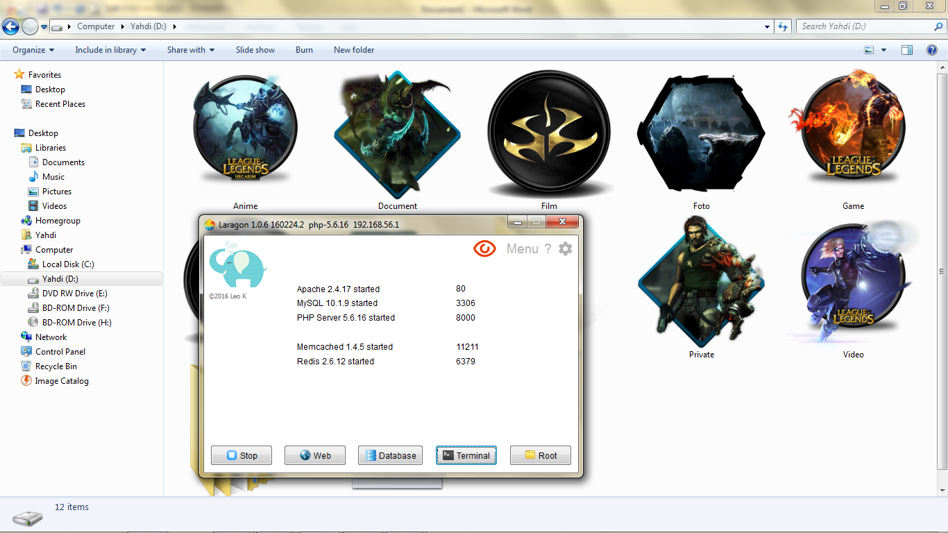

1. **Klik terminal untuk create controller**

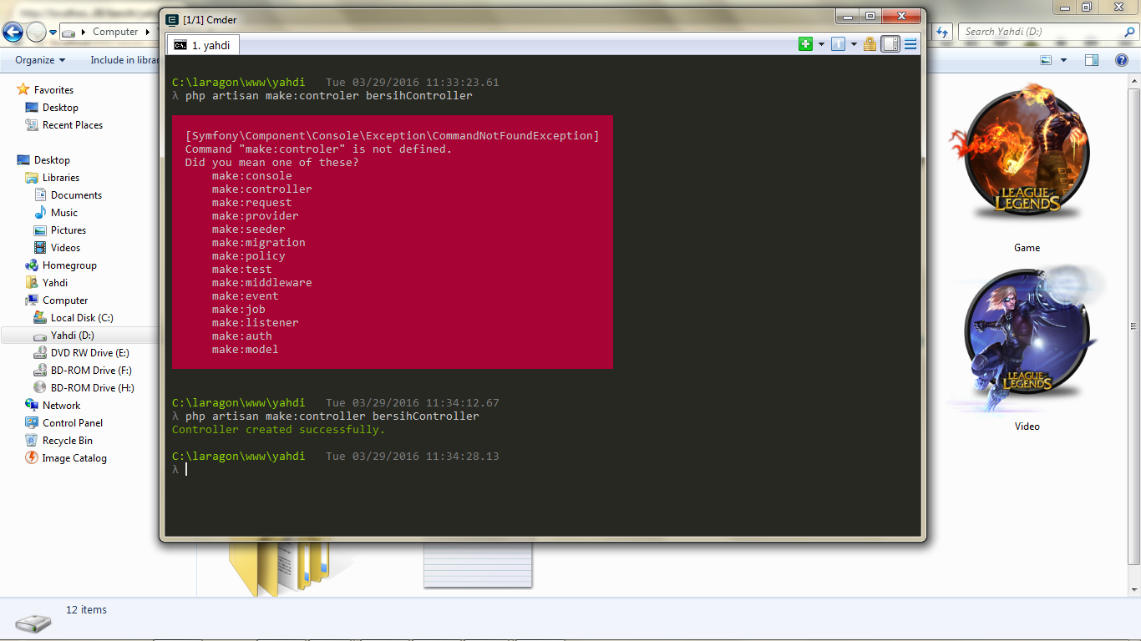

1. **Router .php**

<?php

/*

|--------------------------------------------------------------------------

| Routes File

|--------------------------------------------------------------------------

|

| Here is where you will register all of the routes in an application.

| It's a breeze. Simply tell Laravel the URIs it should respond to

| and give it the controller to call when that URI is requested.

|

*/

Route::get('/', function () {

return view('welcome');

});

Route::get('bersih','bersihController@index');

Route::get('bersih/{nama}','bersihController@profil');

Route::get('satpam','satpamController@index');

Route::get('satpam/{nama}','satpamController@sapa');

/*

|--------------------------------------------------------------------------

| Application Routes

|--------------------------------------------------------------------------

|

| This route group applies the "web" middleware group to every route

| it contains. The "web" middleware group is defined in your HTTP

| kernel and includes session state, CSRF protection, and more.

|

*/

Route::group(['middleware' => ['web']], function () {

//

});

1. **bersihController.php**

<?php

namespace App\Http\Controllers;

use Illuminate\Http\Request;

use App\Http\Requests;

class bersihController extends Controller

{

public function index(){

echo" Hari Bersih";

}

public function profil($nama){

echo "Nama : $nama";

echo " <br>

";

echo "Alamat : Lenteng Agung ";

echo " <br>

";

echo "Lama Pengabdian 2 Tahun";

}

}

1. **Tampilan**
   1. **Localhost:8000/bersih**

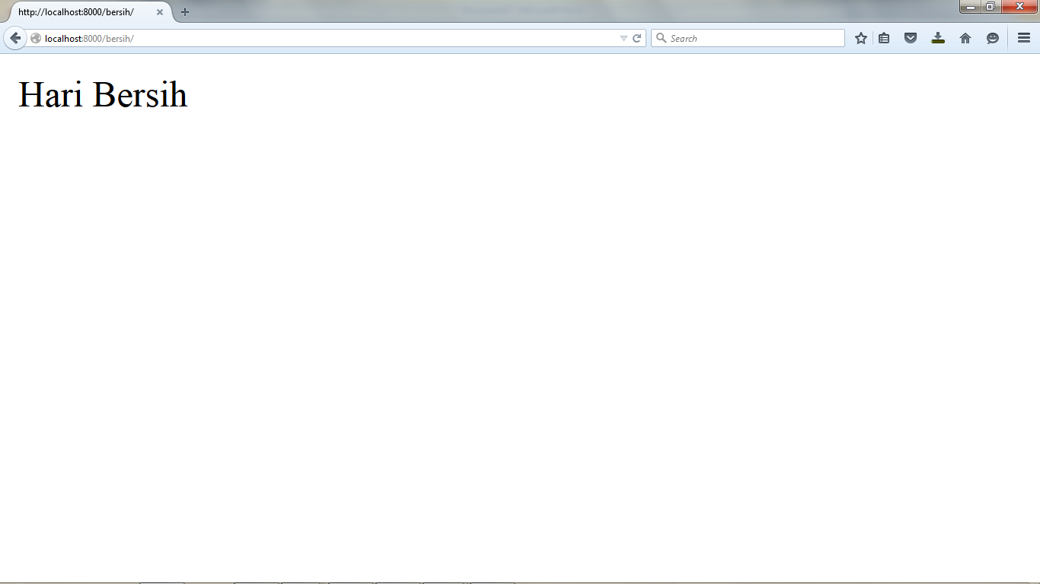

* 1. **Localhost:8000/bersih/yahdi**

